**GUJARAT TECHNOLOGICAL UNIVERSITY**

Chandkheda, Ahmadabad

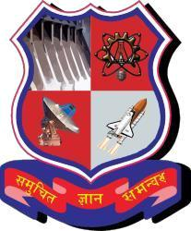Affiliated

A. D. Patel Institute of Technology

A Report On-

Vehicle Tracking Station

Under subject of

DESIGN ENGINEERING – 2A

B. E. III, Semester – V

(Information Technology Branch)

Submitted by Group: 77114

Sr. No Name of student Enrolment No.

1. Patel Vijul 170010116040
2. Shah Neel 170010116050

Prof. Jayandrath Mangrolia

(Faculty Guide)

Dr. Narendra C. Chauhan

Head of the Department

Academic year (2019-2020)

**INDEX**

**1. Introduction .............................................................................. 3**

**2. Canvases..................................................................................... 4**

**3. Prior Art Search......................................................................... 20**

**4. Pre-Design................................................................................... 22**

**5. Summary..................................................................................... 26**

**6. References................................................................................... 27**

**1. Introduction**

* 1. **What is Reverse Engineering?**

Reverse engineering is taking apart an object to see how it works in order to duplicate or enhance the object. The practice, taken from older industries, is now frequently used on computer hardware and software. Software reverse engineering involves reversing a program's machine code (the string of 0s and 1s that are sent to the logic processor) back into the source code that it was written in, using program language statements.

* 1. **Selected existing Project/artefact/component**

We have studied the applications that are currently been working. The GSRTC application is currently providing the features such as timings of a particular bus, route of the bus, etc. Apart from this are some more applications developed by private companies like Rapid Go and Red Bus. These applications also provide the similar features but most of them lacks in accuracy.

**1.3 Disassembling and Analysis of existing Project /artefact/component**

We have analyzed some of the applications that are currently working. Various features that all the applications provide are basic information about the bus such as time of arrival, departure time, route of the bus, etc. The time that is being provided is an estimated time so there are chances of inaccuracy in that. Also changes in the route of the bus are not reflected in the application. The information for all the buses is not provided. Some small and rural route buses are not shown in the application. The application provides the information about the number of seats reserved and the seats that can be booked.

1. **CANVASES**
2. **AEIOU Canvas**

## 1.1 What does AEIOU stands for?

AEIOU is a tool that helps to gather information. **AEIOU** stands for 5 elements to be coded, they are listed below:

A-Activity

E-Environment

I-Interaction

O-Object

U-Users

## 

## 1.2 Activity

## Activities are goal-directed sets of actions paths towards things people want to accomplish. The domain of our project was Gym .We there observed for 2 to 3 days at different gyms and came up with certain common problems such as irrelevant information given by the fitness apps for some exercises .We also notice that there are instructors they don’t work properly. Some People face problems like how to operate machines and what type of exercise is good for them. We have also found there in its parking many vehicles were stolen from last one month. In era of technology they also want to find there lost things as soon as possible.

Our area is gyms so the general activities occur at that place are:

**Activities are:**

Jumping Running Listening Resting Drinking

Dancing Writing Pressing Laughing Shouting

Chatting Interrogate Speaking Cycling Walking

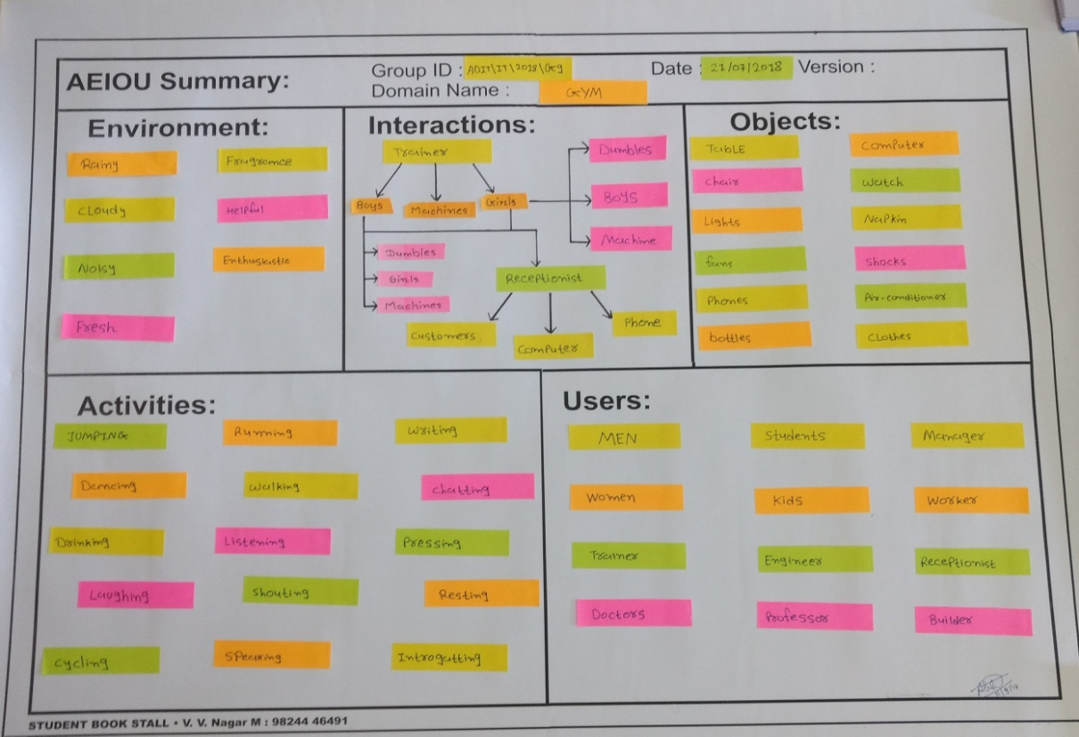

Figure 1.1 Activities

## ENVIRONMENT

Environment includes the entire field where some activities are going on for example, when we enter in gym we listen song and peoples are shouting so the environment becomes noisy.

**Types of environment** at gyms are listed below:

Rainy, Helpful, Fresh, Fragrance, Noisy, Cloudy, Enthusiastic

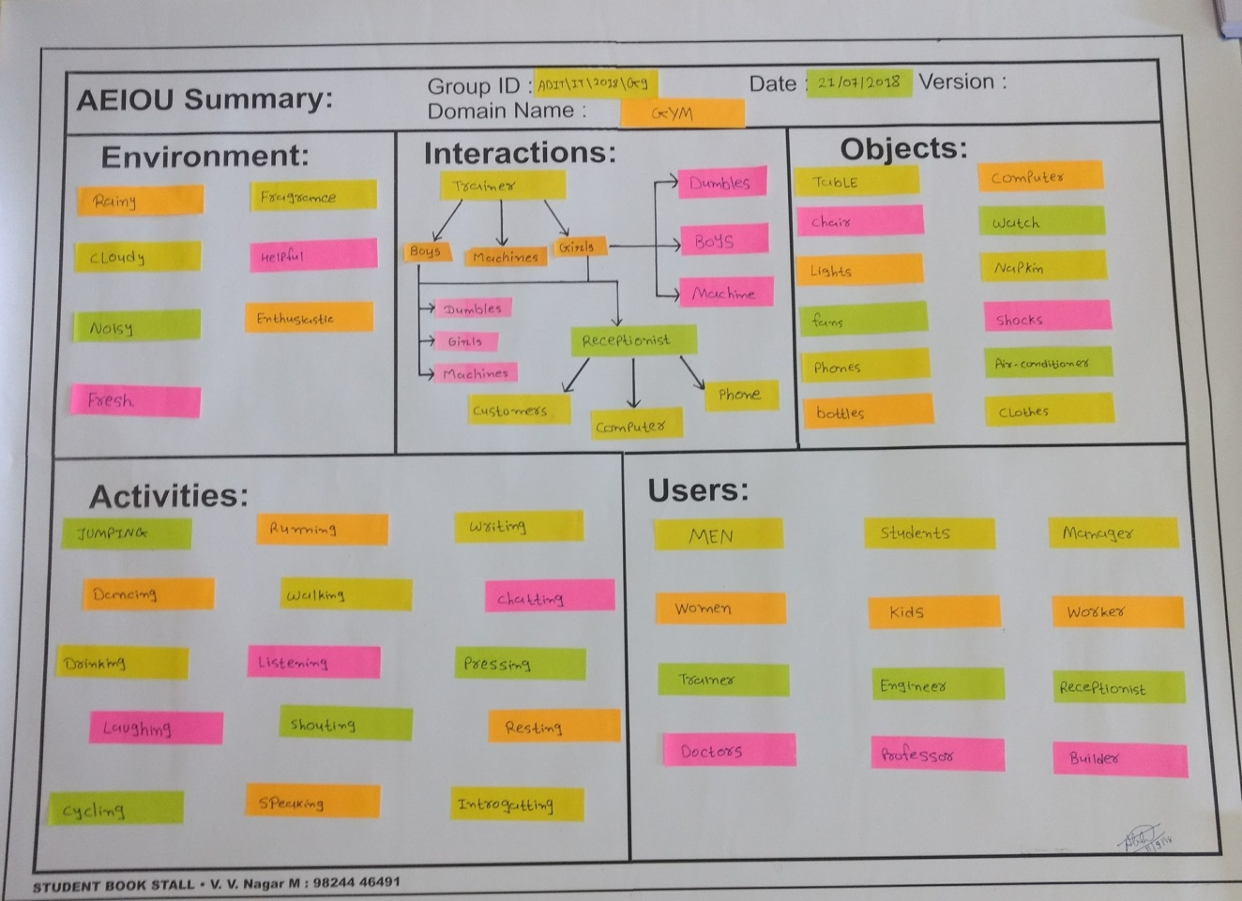

Figure 1.2 Environments

## 1.4 INTERACTION

Interaction means conversation take place person and someone or something else. There are many interaction takes place at gym.

Trainer---Boys---Dumbbell Boys---Girls---Dumbbell

Trainer---Girls---Machine Girls---Boys---Machine

Receptionist---Customers---Computer Receptionist---Customers---Phone

Problems that trainer and customers told us that,

1. Less availability of resources
2. Less awareness about health

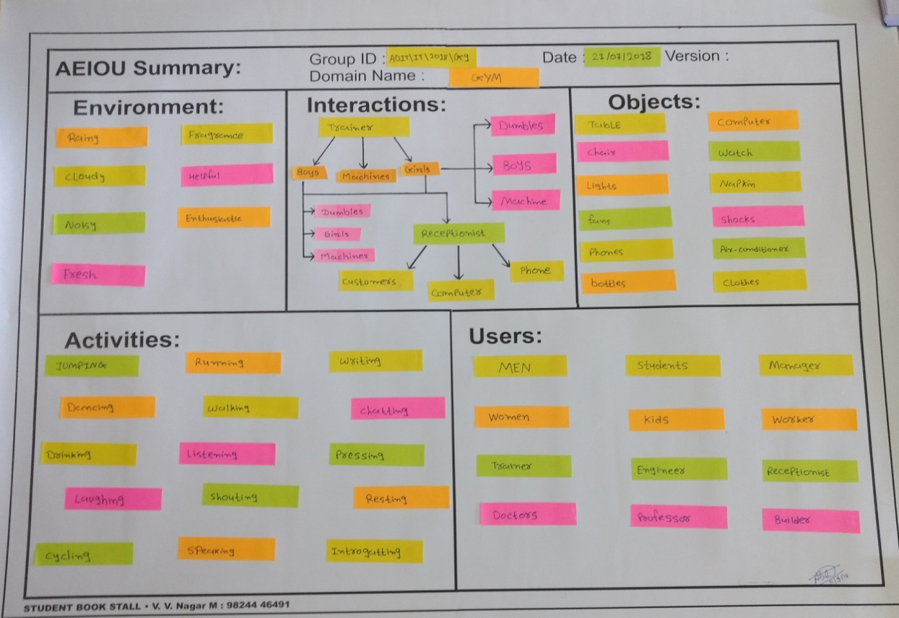

Figure 1.3 Interactions

## 1.5 OBJECT

Object are the devices people have in their environments. There are many objects like fans, machines, mobile phone, bags, loud speaker, and chairs.

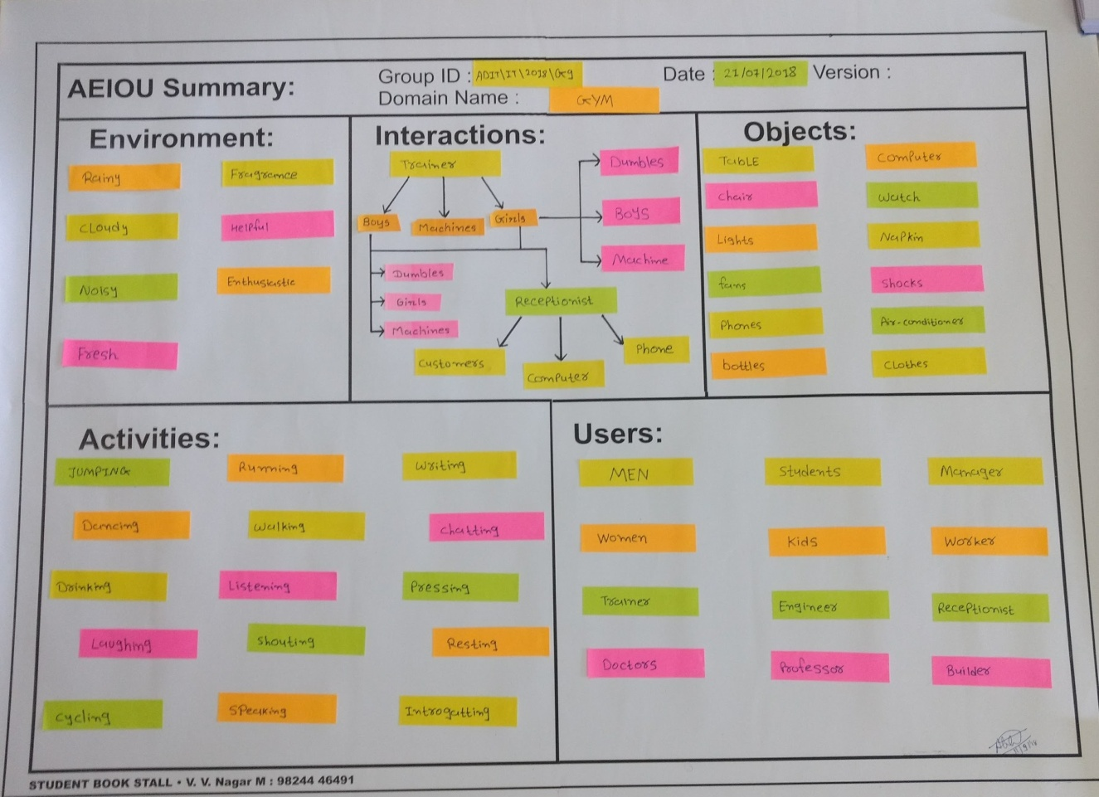

Figure 1.4 Objects

## 1.6 USERS

Users are the people whose behaviours, action and need are observed. There are generally many type of users such as student, professor, old age people, women, etc.

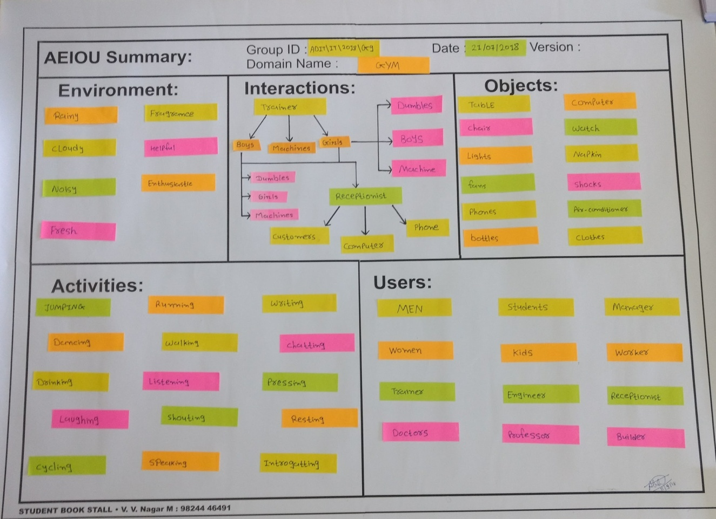

Figure 1.5 Users

**1.7 Snapshot of AEIOU Canvas**

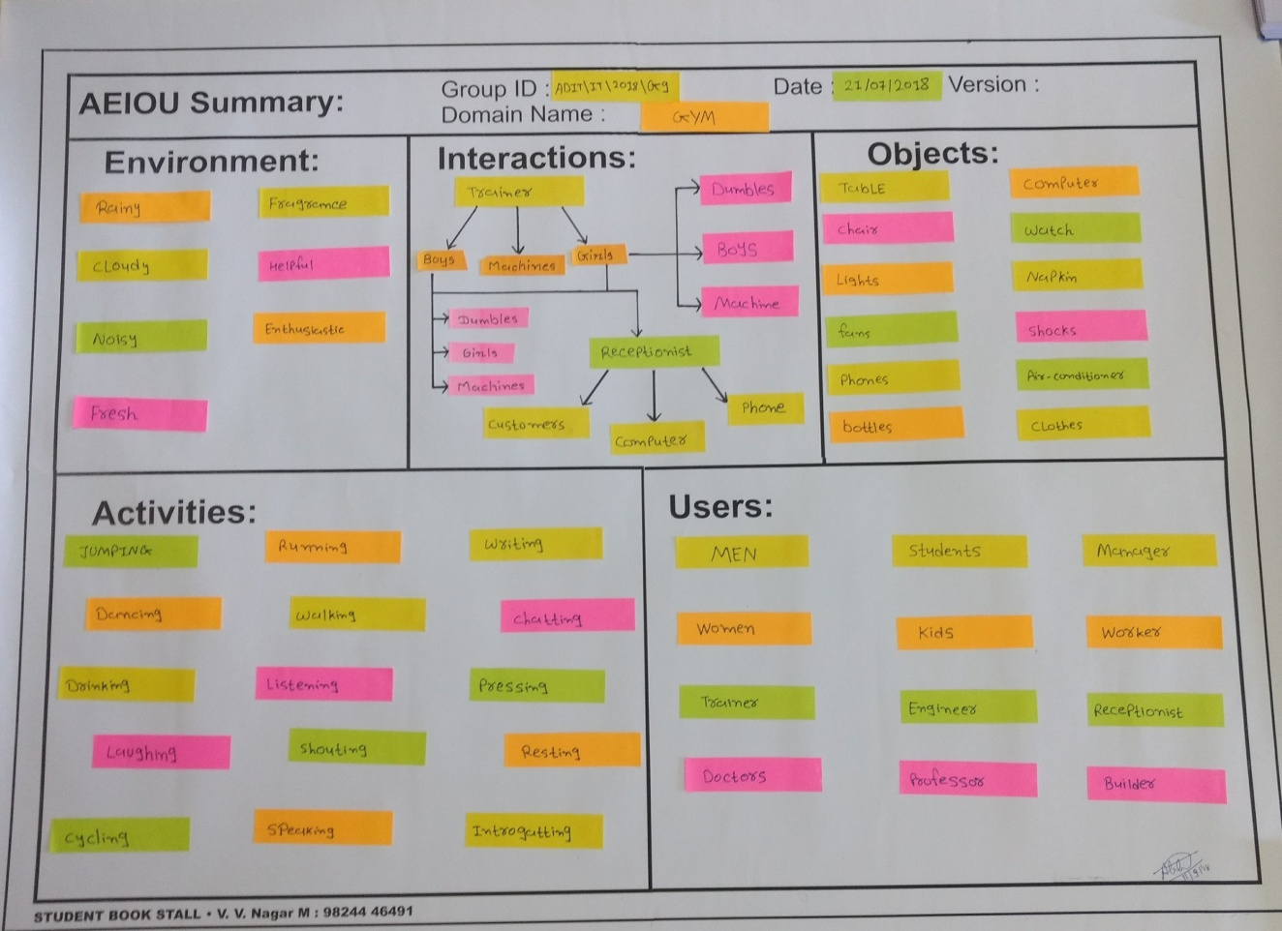

Figure 1.6 AEIOU Canvas

1. **Mind Map**

* **Mind mapping** is a way to show and structure ideas visually. It is hierarchical in terms of main and sub topics. In Mind Map key branches has close relationship with the main topic.
* **Mind map** shows living and non-living things like objects, fees, routine days, etc.
* In our Mind map we show that there are many living and non-living things.
  1. **Objects:**

There are different objects I gym like **AC**, **Dumbbells**, **Computer**, **Bottles**, **Bags**, **Cycles**, and many more.

**2.2 Activities:**

Different activities are done in gym by people. Like some people are doing **Lifting**, Few of them are busy in **Chatting**, One of them is **interrogating** his self, Receptionist is **Typing**, Peoples are **Listening** songs while doing exercise, and many activities like **Resting**, **Cycling**, **Drinking**, **Dancing**, **Talking**, **Running** are done by them.

**2.3 Peoples:**

There are different peoples in gym we can differentiate them by Age and person. Like in **age** there are two types of people **above 16** and **above 18**.

In **person** category we differentiate them by their professions like **Engineers**, **Students**, **Doctor**, **Teacher**, **Builder**, **House-wives**, **Athletes**, Etc.

**2.4 Atmosphere:**

In gym we feel atmosphere like enthusiastic, energetic, fresh, cool, helpful, and optimistic.

* 1. **Timing:**

Timing of gym is based on days. In regular days there are two timing morning 6:00 to 11:00 am and evening 4:00 to 8:00 pm.

* 1. **Fee structure:**

Customer can pay his fees by **1 month**, **3 months**, **6 months** and **annually**. Payment is of two type **personal trainer** and **general trainer** in 1 month personal trainer **3500/**- and general trainer **1000/-**. Like vise in 3 month payment personal trainer **6500/-** and general trainer **4500/-**, in 6 months personal trainer **11000/-** and general trainer **7500/-** and in annually payment method personal trainer cost is **19000/-** and general trainer cost is **12000/-**

* 1. **Snapshot of AEIOU Canvas**.

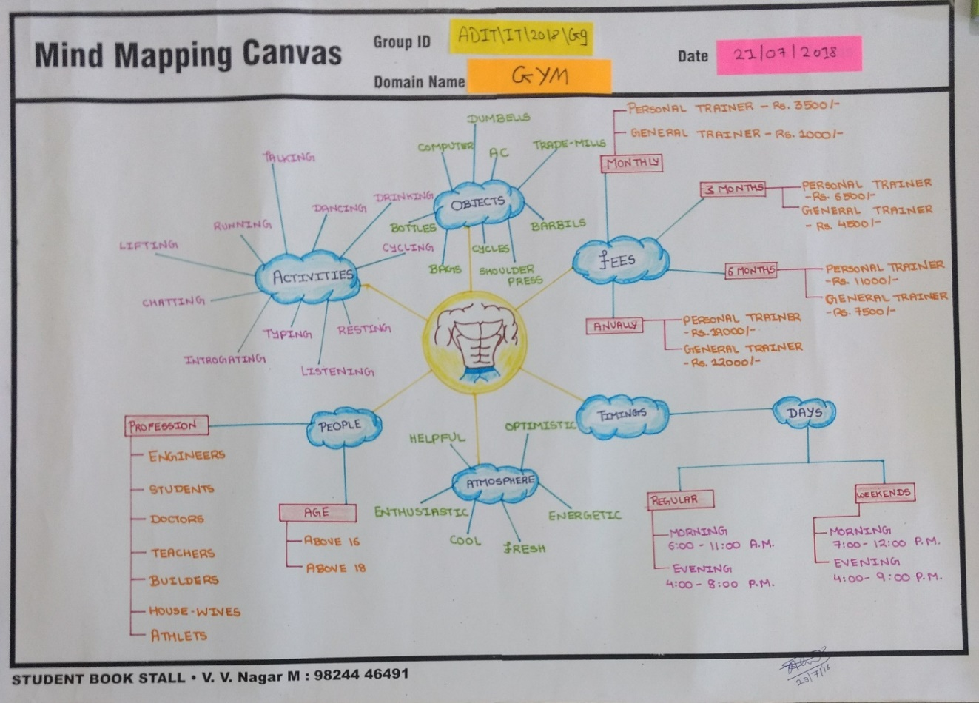

Figure 2.1 MIND MAP

1. **Empathy Mapping Canvas**

The Empathy Map is a great powerful tool that helps putting yourself inside the head of a person you might be looking at as a prospective customer or product user. It allows you to quickly grasp their experience and where they are coming from. An empathy map is a collaborative tool teams can use to gain a deeper insight into their customers. Much like a user persona, an empathy map can represent a group of users, such as a customer segment.

## 3.1 Who are user and stack holder?

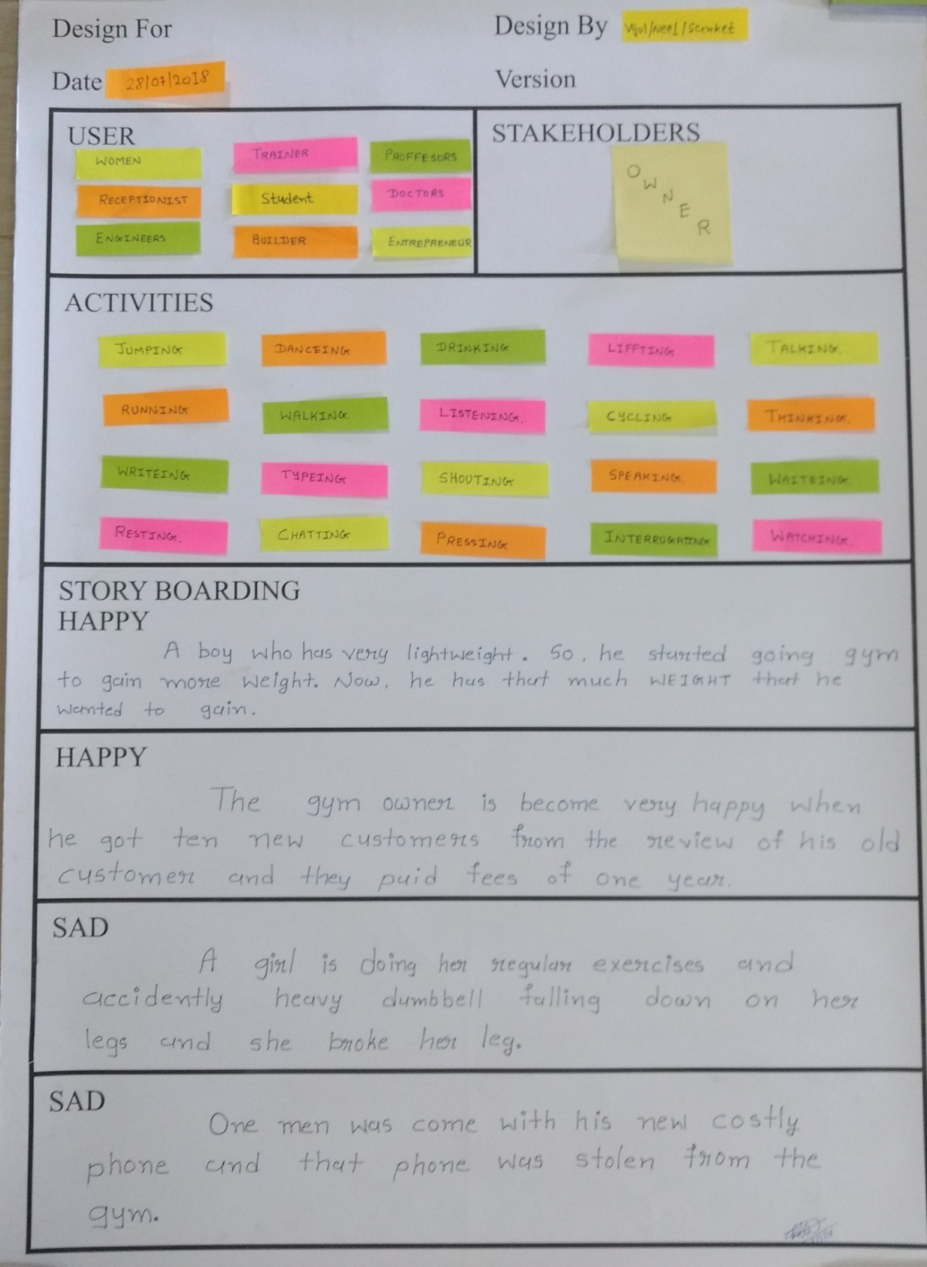

Figure 3.1 Users and Stakeholders

* In this stage, we find the various users which are directly or indirectly related to our project.

For ex: Women Student Doctor Receptionist

Trainer Engineer Builder Entrepreneur

* Stakeholders mean a person or organization with an interest.

For example: Owner

## 3.2 Activities



Figure 3.2 Activities

In activities, we observe various activities like Jumping, Running, Listening, Resting, Drinking, Dancing, Writing, Pressing, Laughing, Shouting, Chatting, Interrogating, Speaking, Cycling, Walking.

## 3.3 Story Boarding

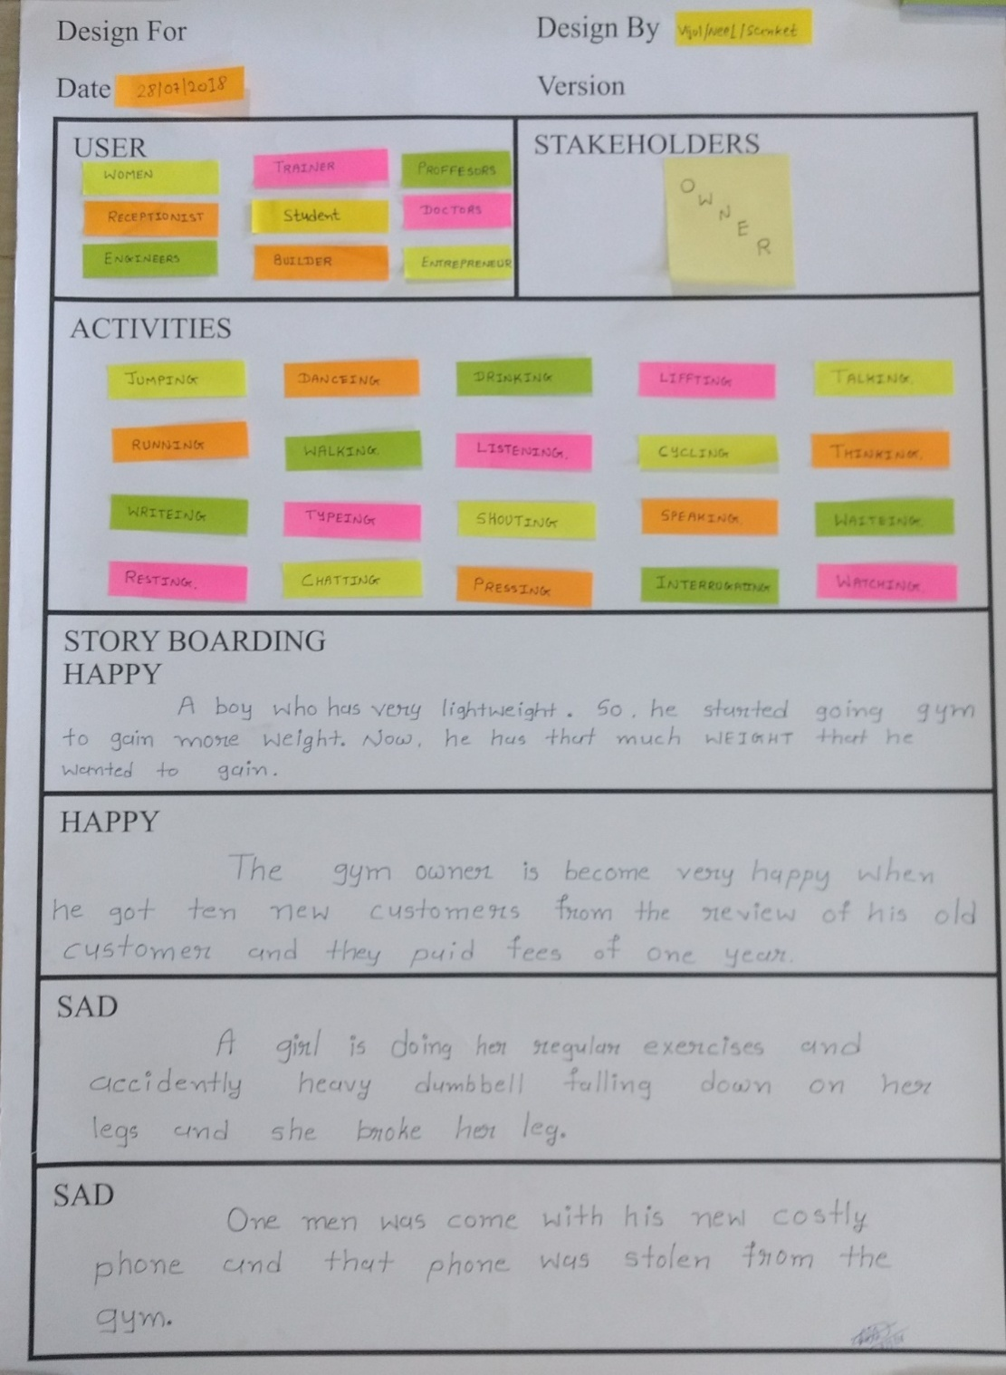

Figure 3.3 Story

• **HAPPY**:

A boy who has very Light weight. So he started going to gym to gain more weight. Now he has that much weight that he wanted to gain.

• **HAPPY**:

The gym owner is become very happy when he got 10 new customers from the review of his old customers and they paid fees of one year.

• **SAD**:

A girl was doing her regular exercise and accidently heavy dumbbell falling down on her legs & her legs broke.

• **SAD:**

One man was come with his new costly phone and that phone was stolen from the gym.

## 3.4 Snapshot of EMPATHY Canvas

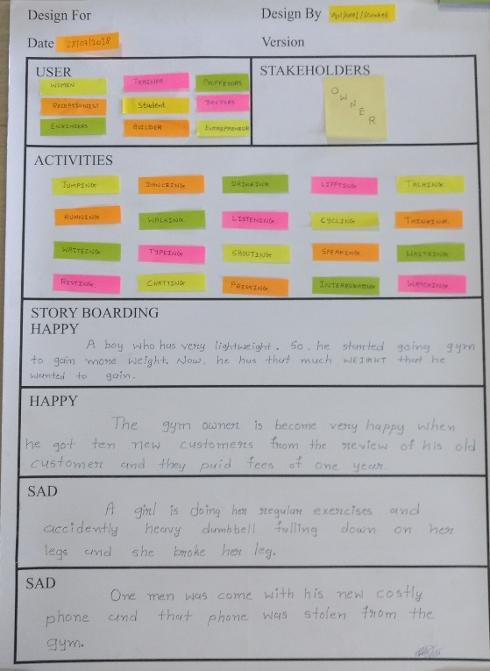

Figure 3.4 EMPATHY CANVAS

**4. Ideation Canvas**

* **Ideation** is the creative process of generating, developing, and communicating new ideas, where an idea is understood as a basic element of thought that can be either visual, concrete, or abstract.
* **Ideation** comprises all stages of a thought cycle, from innovation, to development, to actualization.
* For Ideation Canvas From the user canvas, you have an idea what are the people? In ideation canvas, you have to carry out which type of activities is related to your project and people? What is situation and location regarding to activities? Then after you find the possible solutions. It is depend or not depend to your activities.

**4.1 People:**

Women Student Doctor Receptionist

Trainer Engineer Builder Entrepreneur

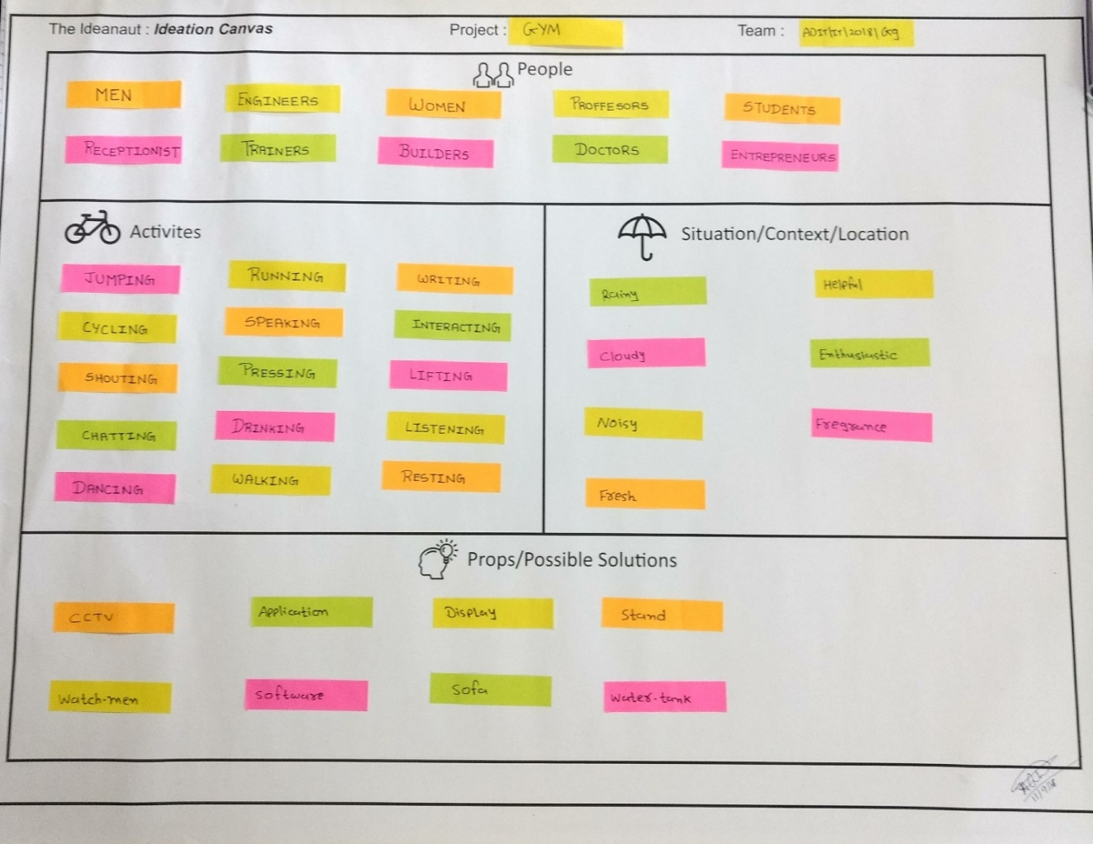

Figure 4.1 People

**4.2Activities:**

Jumping Running Lifting Resting Drinking

Dancing Writing Pressing Interacting Shouting

Chatting Pressing Speaking Cycling Walking



Figure 4.2 Activities

**4.3Situation/Context/Location:**

Rainy Helpful Fresh Enthusiastic

Fragrance Noisy Cloudy



Figure 4.3 Situation/Context/Location

**4.4Props/Possible Solutions:**

CCTV Application Display Stand

Watch-men Software Sofa Water tank



Figure 4.4 Props/Possible Solutions

## 4.5 Snapshot of IDEATION Canvas

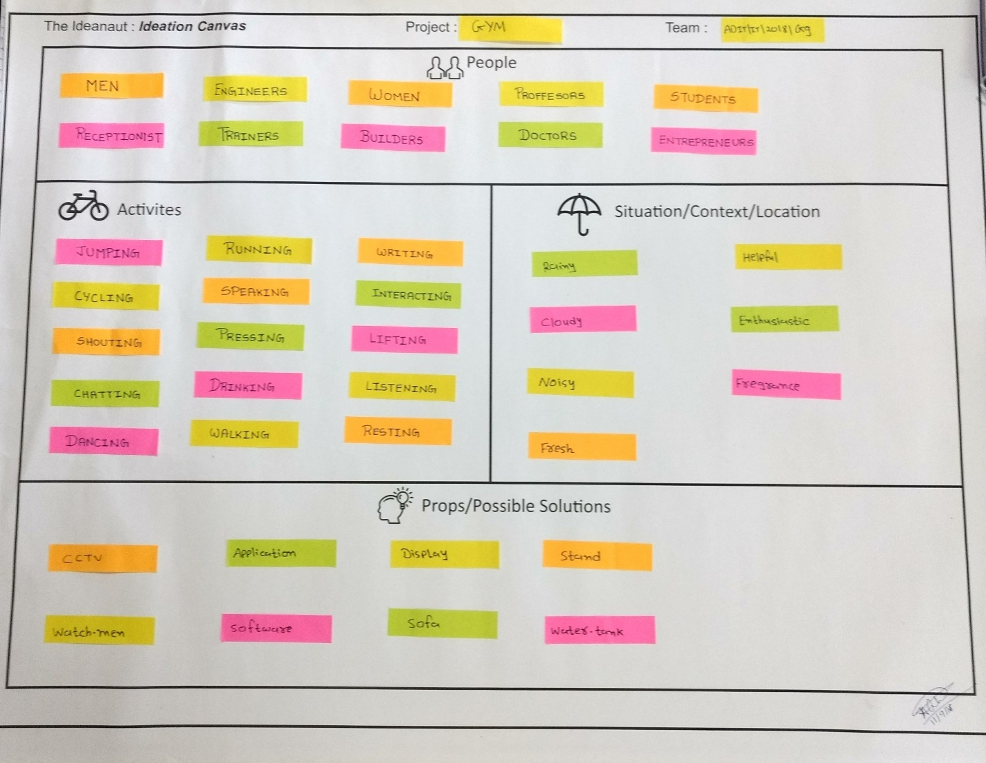Figure 4.5 Ideation Canvas

**5. Product Development Canvas**

## 5.1 Purpose

In the product development canvas we had to write about the purpose of our topic. Our purpose is to help the local person. Our purpose is to notify people about their lost vehicle. Through which it will be helpful to everyone as from that information they will be able to decide what action they have to take.

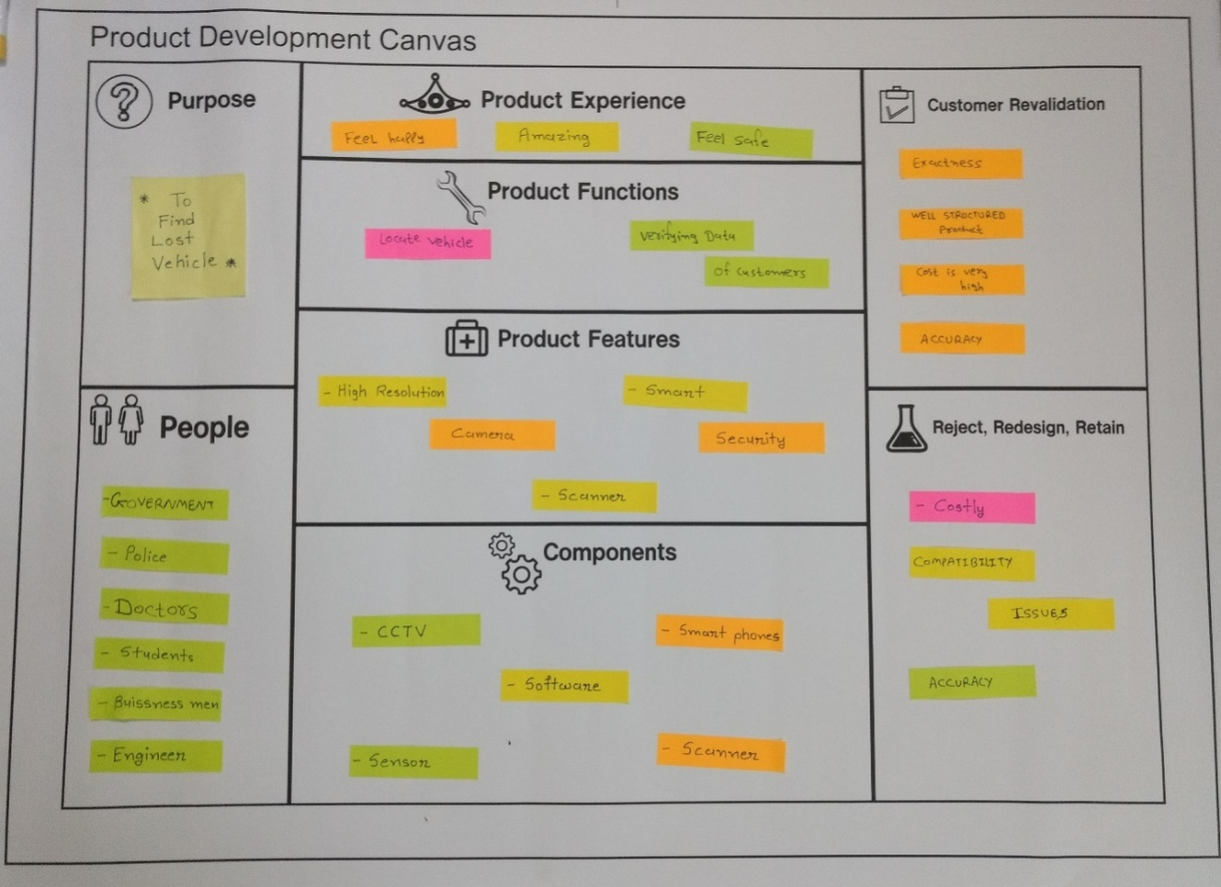

Figure 5.1 Purpose

## 5.2 PEOPLE

The people to whom our product may be useful are the persons who wants to find their vehicle.

* Government
* Police
* Doctors
* Student
* Business men

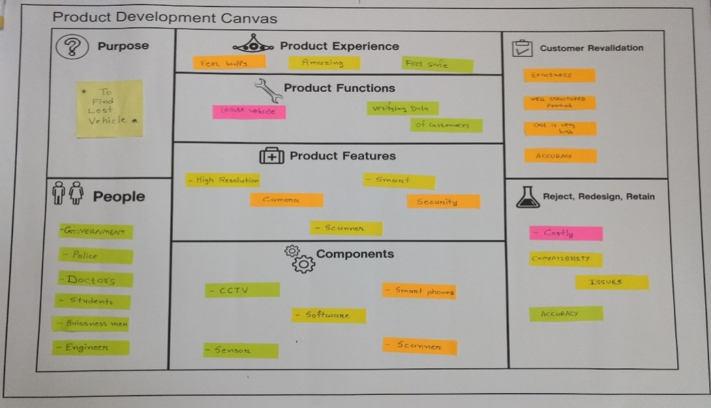

Figure 5.2 People

## 5.3 PRODUCT FUNCTIONS

Our product is to locate the vehicle in the stolen vehicle data base and also verifying the data entered by the customers.

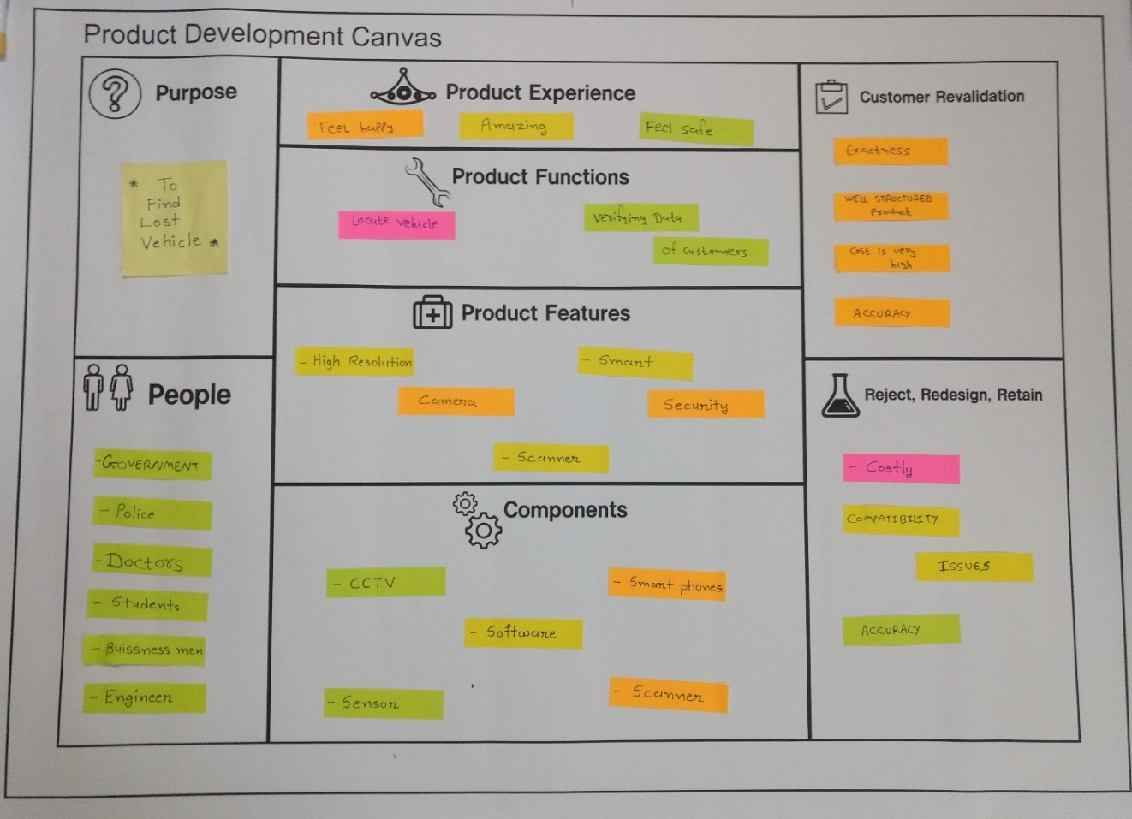

Figure 5.3 product functions

## 5.4 PRODUCT FEATURE AND COMPONENTS

* High Resolution Camera
* Smart Security
* Scanner

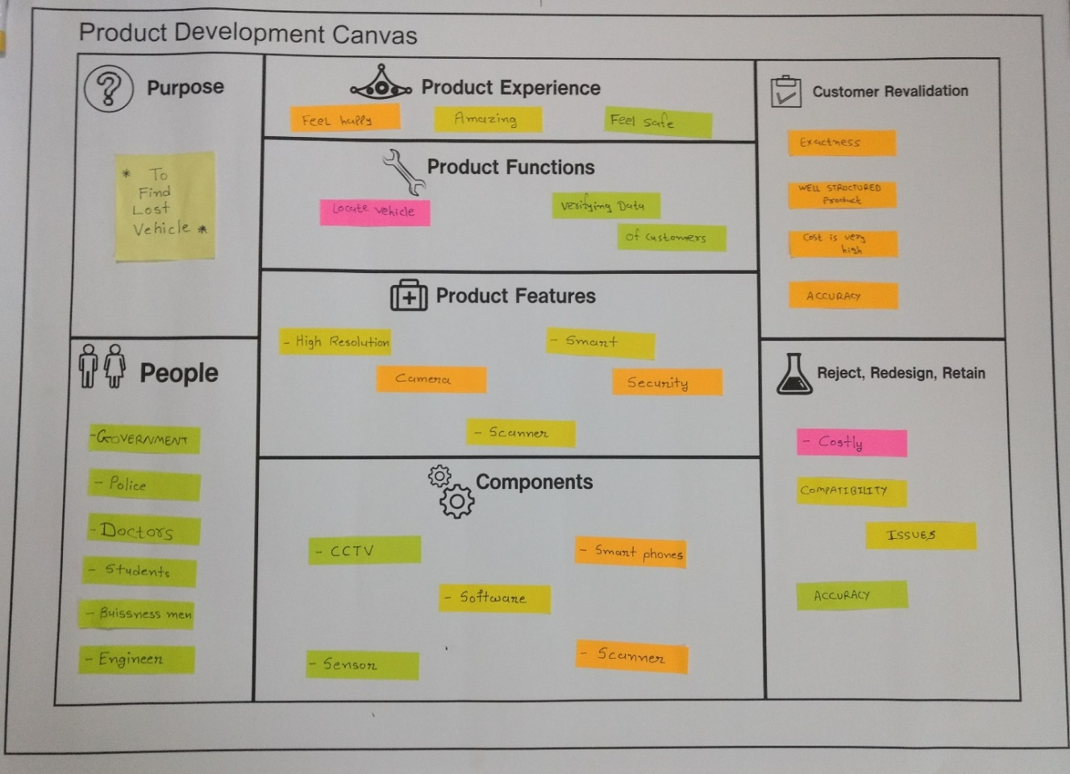

Figure 5.4 Product features

Components means things to be require to make our product.

* CCTV
* Software
* Smart Phone
* Sensor
* Scanner

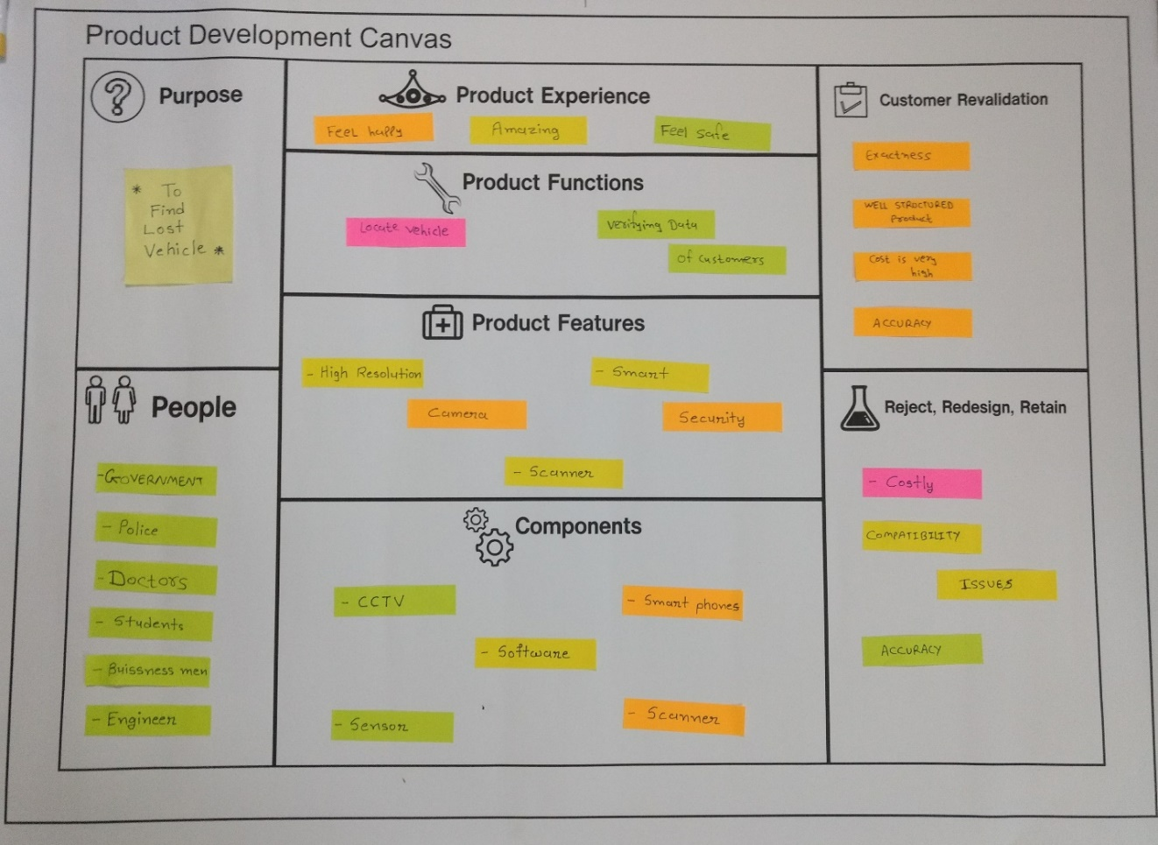

Figure 5.5 Components

## 5.5 CUSTOMER REVALIDATION,PRODUCT EXPERIENCE AND REJECT,REDESIGN,RETAIN

In these sections reviews taken from the people for our idea are kept. People gave their feedback and their suggestions regarding to our product and we retain, redesign and reject the features.



Figure 5.6 Customer Revalidation



Figure 5.7 Reject, Redesign, Retain

## 

## 5.6 PRODUCT EXPERIENCE

In these the customers who used our product tells his experience about the product.

We asked some of people and explained them about our product from that they shared some points such as it helps to make our product easy to use for everyone.



Figure 5.8 Product Experience

## 5.7 Snapshot of Product Development Canvas

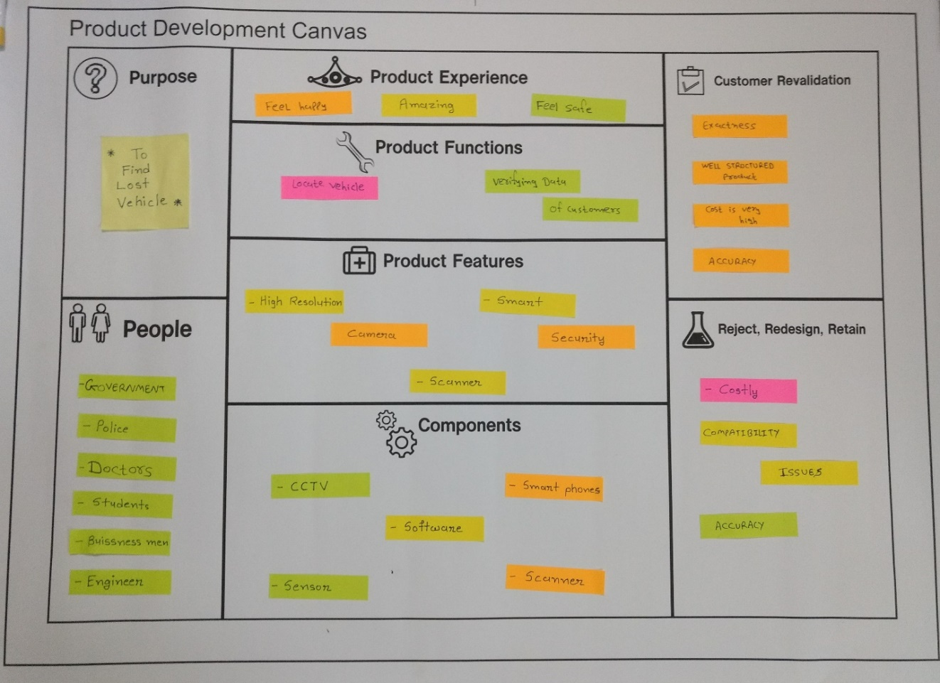

Figure 5.9 Product Development Canvas

**3. Prior Art Search**

**Research Paper Summary**

# [Naveen Balaji Gowthaman](https://www.researchgate.net/profile/Naveen_Balaji_Gowthaman),“Smart Vehicle Number Plate Detection System for Different Countries Using an Improved Segmentation Method” [, Imperial Journal of Interdisciplinary Research (IJIR)](https://www.researchgate.net/journal/2454-1362_Imperial_Journal_of_Interdisciplinary_Research_IJIR) 03(06):263-268 · June 2017

**Abstraction:**

Day by day the use of vehicles in our life is rising exponentially and as increasing vehicles are violating the rules of traffic, theft of vehicles, ingoing to restricted areas, abnormal number of accidents lead to upturn in the crime rates linearly. For any vehicle to be acknowledged, vehicle license plate detection will play a main significant job in this active world. The commonly used in field of safetyand security system, LPDR plays a significant role and we need to identify vehicles registration number at anevident distance for finding the vehicle.The methodology which we have used is modest but appropriate. First the segmented of all characters in the image (Licence Plate). Ultimately, the recognition of each character is done. The pattern matching method is used for recognition each character in the vehicle license plate.

1. Jinlin Liu, Qiang Chen and Chen Zhang, “**Vehicle Recognition using Vibe And SVM**” August 2016 6th volume of An international Journal (Computer Science & Engineering)

**Abstraction:**

Video surveillance is becoming more and more important forsocial security, law enforcement, social order,military, and other social problems. In order to manage parking information effectively, this vehicle detection method is presented. In general, motion detection plays an important role in video surveillance systems. In this paper, firstly this system uses ViBe method to extract the foreground object, then extracts HOG features on the performance of the ROI of images. At last this paper presents Support vector machine for vehicle recognition. The results of this test show that, the recognition rate of vehicle’s model in this recognition system is up the industrial application standard.

1. Nerey H Mvungi, “**Vehicle Plate Number Detection and Recognition Using Improved Algorithm**” January 2014 Computer Engineering and Intelligent Systems Vol.5, No.10, 2014

**Abstraction:**

The growing Tanzanian population currently estimated to be 48 Million people and their use of vehicles as means of transport has kept increasing making enforcing traffic rules and regulations among road users a major challenge. This calls for a need to have an automated system that monitors the motorists with a pre-defined sense of intelligence. A Vehicle Detection and Recognition Algorithm which can provide automated access to relevant information to a number plate from information systems containing and managing databases on vehicle and their movements is required. This paper presents work on developed algorithm that localizes plate area, extract and segment character, and finally recognizes and interprets registration number from vehicle image. MATLAB R2012b Simulation software with Image Processing toolbox is employed. HSV color space image, morphological and statistical analysis operations were integrated and employed to a vehicle image to compute plate number area. In segmentation the properties like aspect ratio, extent, and area ratio were important measurement parameters. Finally, the template matching database and statistical character extracted from car image was correlated to recognize alphanumeric character to deduce car registration number.

**4. Pre-Design**

**4.1 Learning Need Matrix**

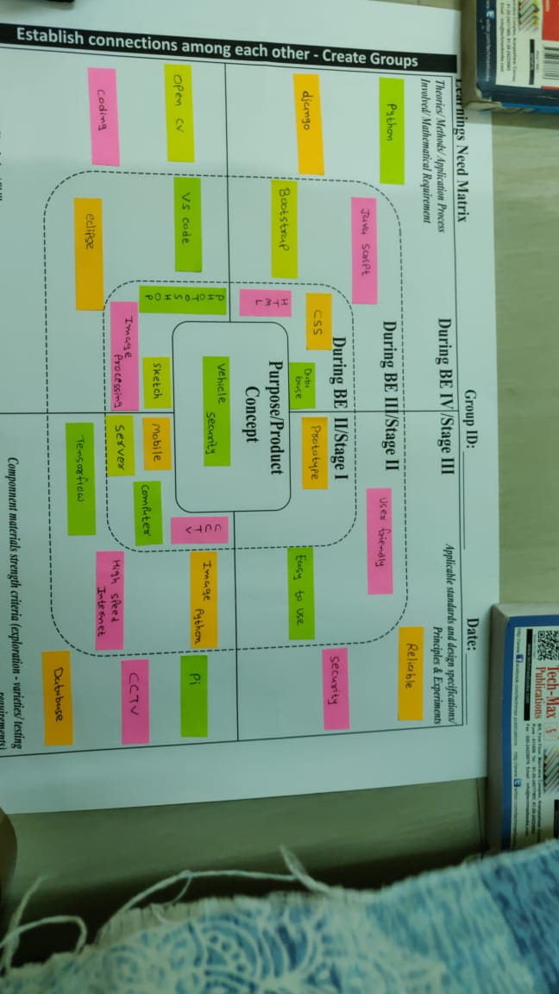

Figure 4.1 LNM Canvas

A learning need matrix helps to assess the required skills for a project or team. In order to successfully implement a skills matrix, you need to create an overview of the skills that are required to complete the job or project successfully.

In this sheet we come to know what kind of softwares and platform are required for the purpose of app and web development. We came to know about the needs of this software development. Stage wise implementation has been discussed.

**4.2 Prototype**

This is the flow of our product which name is **“VEHICLE TRACKING STATION”.**

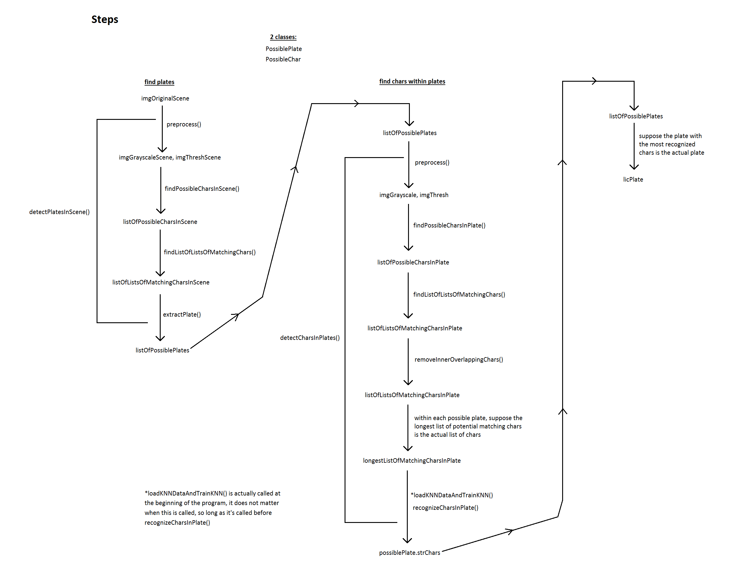Figure 2.1 Prototype-I

Picture shows the flow of how product will work.



Figure 2.2 Prototype-I

Above fig shows the original picture of the object which will be processed and from that we will found the number plate.

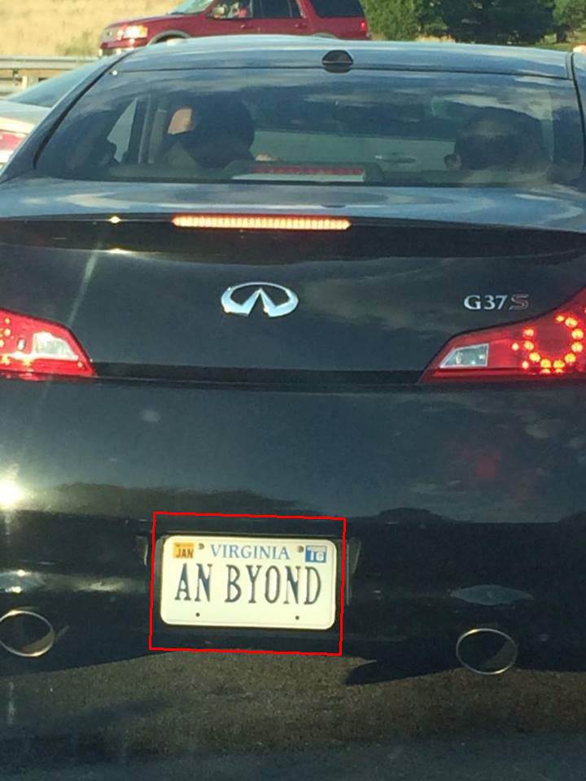

Figure 2.3 Prototype-I

Above picture shows the processed image of given frame (photo). In the photo we can see the red box which will be drawn on number plate.

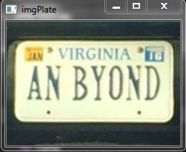

Figure 2.4 Prototype-I

Above picture shows the extracted number plate from the image which will be further used for number plate recognition.

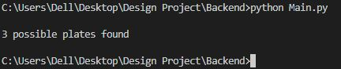

Figure 2.5 Prototype-I

After completing process it will give total number of possible number plates that would be found in picture and from that which would optimal that will be extracted

**4.3 Pre-Design Calculations**

**4.3.1 Technological**

The main aim to develop the product is to help people to find lost vehicle. An application will be developed which will provide various features such as where their vehicle was last located. To know the location of their vehicle. The last location of vehicle is based on record which will be stored in our database using camera.

**4.3.2 Aesthetics**

The app will be designed in such a way that it can be useful in attracting more people. All the features will be arranged in such a manner that the app can be used easily. People will not find any difficulty in accessing any feature of the app. Also the map will be provided in the app which will help to give the progress of their complain. These features will make the app look good and easier to use.

**4.3.3 Ergonomics**

Everyone nowadays uses a mobile phone so it will be an easy task for them to use an application which provides almost all the information. Same features of the app will be visible on a website and people can access the facility from there also.

**4.3.4 Environment**

Numbers of people were cheated everyday as their vehicles were stolen. So, it is important to help those and reduce crime rate of our city. Our app and website will provide them help using security camera which will be at circles and on road.

**4.3.5 Cost**

The cost for the product will be based on what type of database we will use. If we use google or amazon then it will cost because of business account and we need permission to access security camera which is already situated on every circles and chowks.

**5. Summary**

Our project name is Vehicle Tracking Station; In this project till now we have completed some backend task like detect number plates from an image using python opencv library. From now we are going to use it in live streaming and make application which will be helpful for users.

Our project will help users to find their lost vehicle, when someone lost his /her vehicle they will register in our app and as an when his vehicle is detected in any of security camera which are situated at circles, etc. Our project simply informs user that his/her vehicle was detected at this place at this time. So in future we are going to implement frontend work and we are willing to make an android app.

1. **References**
2. <https://www.researchgate.net/publication/317401424_Smart_Vehicle_Number_Plate_Detection_System_for_Different_Countries_Using_an_Improved_Segmentation_Method><https://ieeexplore.ieee.org/document/6740258>
3. <https://www.academia.edu/37491481/VEHICLE_RECOGNITION_USING_VIBE_AND_SVM>
4. <https://www.researchgate.net/publication/312529686_Vehicle_Plate_Number_Detection_and_Recognition_Using_Improved_Algorithm>
5. <https://ieeexplore.ieee.org/document/6631707>